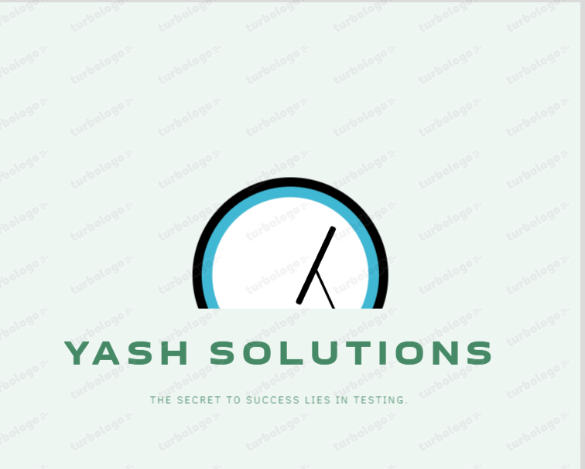

Test PLAN

Project Name: TutorialsNinja Web Application

Prepared by: Solaytic

Date: May 16th, 2023

Table of Contents

Overview 2

Scope 3

Inclusions 3

Test Environments 3

Exclusions 3

Test Strategy 4

Problem Tracking and Test Tracking Procedures 5

Roles/Responsibilities 6

Test Schedule 7

Test Deliverables 8

Pricing 9

Entry and Exit Criteria 10

Suspension and Resumption Criteria 11

Tools 12

Risks and Mitigations 13

Approvals 14

# Overview

As part of the project, ‘KodNest has asked Yash Solutions to test few functionalities of ‘http://tutorialsninja.com/demo/” web application.

This document serves as high level test planning document with details on the scope of the project, test strategy, test schedule and resource requirements, test deliverables and schedule.

# Scope

The scope of the project includes testing the following features of ‘http://tutorialsninja.com/demo/’ web application.

## Inclusions

* Register
* Login & Logout
* Forgot Password
* Search
* Product Compare
* Product Display Page
* Add to Cart
* Wish List
* Shopping Cart
* Currencies
* Home Page
* Checkout Page
* My Account Page
* Order History Page
* Downloads Page
* Contact Us Page
* Menu Options
* Footer Options
* Category Pages

From our understanding, we believe above functional areas need to be Tested.

## Test Environments

* Windows 10 – Chrome, Firefox, IE 11 and Edge
* Mac OS – Safari Browser
* Linux Ubuntu OS – Firefox
* Android Mobile OS – Chrome
* iPhone Mobile OS - Safari

## Exclusions

* All the features except that are mentioned under ‘Inclusions’
* Any third-party features or Payment gateways
* Test Automation

# Test Strategy

‘Yash Solutions’ has communicated with ‘KodNest’ and has understood that we need to perform Functional Testing of all the functionalities mentioned in the above Scope section.

As part of Functional Testing, we will follow the below approach for Testing:

Step#1 – Creation of Test Scenarios and Test Cases for the different features in scope.

* We will apply several Test Designing techniques while creating Test Cases
  + Equivalence Class Partition
  + Boundary Value Analysis
  + Decision Table Testing
  + State Transition Testing
  + Use Case Testing
* We also use our expertise in creating Test Cases by applying the below:
  + Error Guessing
  + Exploratory Testing
* We prioritise the Test Cases

Step#2 – Our Testing process, when we get an Application for Testing:

* Firstly, we will perform Smoke Testing to check whether the different and important functionalities of the application are working.
* We reject the build, if the Smoke Testing fails and will wait for the stable build before performing in depth testing of the application functionalities.
* Once we receive a stable build, which passes Smoke Testing, we perform in depth testing using the Test Cases created.
* Multiple Test Resources will be testing the same Application on Multiple Supported Environments simultaneously.
* We then report the bugs in the ‘Zoho’ bug tracking tool and send you the defect found on that day in a status end of the day email.
* As part of the Testing, we will perform the below types of Testing:
  + Smoke Testing and Sanity Testing
  + Regression Testing and Retesting
  + Usability Testing, UI Testing and Accessibility Testing
* We repeat Test Cycles until we get the quality product.

Step#3 – We will follow the below best practices to make our Testing better:

* Context Driven Testing – We will be performing Testing as per the context of the given application.
* Shift Left Testing – We will start testing from the beginning stages of the development itself, instead of waiting for the stable build.
* Exploratory Testing – Using our expertise we will perform Exploratory Testing, apart from the normal execution of the Test cases.
* End to End Flow Testing – We will test the end-to-end scenario which involve multiple functionalities to simulate the end user flows.

# Problem Tracking and Test Tracking Procedures

**Defect Reporting Procedure:**

During the test execution –

* Any deviation from expected behaviour by the application will be noted. If it can’t be reported as a defect, it’d be reported as an observation/issue or posed as a question.
* Any usability issues will also be reported.
* After discovery of a defect, it will be retested to verify reproducibility of the defect. Screenshots with steps to reproduce are documented.
* Every day, at the end of the test execution, defects encountered will be sent along with the observations.

Note:

* Defects will be documented in a word document.
* Test scenarios and Test cases will be documented in an excel document.

# Roles/Responsibilities

|  |  |  |
| --- | --- | --- |
| Name | Role | Responsibilities |
| Dhanraj Errum | Test Manager | * Escalations |
| Yashaswi Kushal | Test Lead | * Create the Test Plan and get the client signoffs * Interact with the application, create and execute the test cases * Report defects * Coordinate the test execution. Verify validity of the defects being reported. * Submit daily issue updates and summary defect reports to the client. * Attend any meeting with client. |
| Mahesh Mehtha | Senior Test Engineer | * Interact with the application * Create and Execute the Test cases. * Report defects |
| Kavitha Appam | Test Engineer | * Interact with the application * Execute the Test cases. * Report defects |

# Test Schedule

Following is the test schedule planned for the project –

|  |  |
| --- | --- |
| Task | Time Duration |
| * Creating Test Plan | June 29th, 2023 to June 30th, 2023 |
| * Test Case Creation | June 30th, 2023 to July 20th, 2023 |
| * Test Case Execution | July 20th, 2023 to August 20th, 2023 |
| * Summary Reports Submission | August 20th, 2023 |

# Test Deliverables

The following are to be delivered to the client:

|  |  |  |  |
| --- | --- | --- | --- |
| Deliverables | Description | Responsible Owner | Target Completion Date |
| Test Plan | Details on the scope of the Project, test strategy, test schedule, resource requirements, test deliverables and schedule | KodNest | June 30th, 2023 |
| Functional Test Cases | Test Cases created for the scope defined | KodNest | July 20th, 2023 |
| Defect Reports | Detailed description of the defects identified along with screenshots and steps to reproduce on a daily basis. | KodNest | NA |
| Summary Reports | Summary Reports –  Bugs by Bug#,  Bugs by Functional Area and  Bugs by Priority | KodNest | August 20th, 2023 |

# Pricing

Will be shared by Test Manager separately.

# Entry and Exit Criteria

The below are the entry and exit criteria for every phase of Software Testing Life Cycle:

**Requirement Analysis**

Entry Criteria:

* Once the testing team receives the Requirements Documents or details about the Project

Exit Criteria:

* List of Requirements are explored and understood by the Testing team
* Doubts are cleared

**Test Planning**

Entry Criteria:

* Testable Requirements derived from the given Requirements Documents or Project details
* Doubts are cleared

Exit Criteria:

* Test Plan document (includes Test Strategy) is signed-off by the Client (TutorialsNinja)

**Test Designing**

Entry Criteria:

* Test Plan Document is signed-off by the Client

Exit Criteria:

* Test Scenarios and Test Cases Documents are signed-off by the Client

**Test Execution**

Entry Criteria:

* Test Scenarios and Test Cases Documents are signed-off by the Client
* Application is ready for Testing

Exit Criteria:

* Test Case Reports, Defect Reports are ready

**Test Closure**

Entry Criteria:

* Test Case Reports, Defect Reports are ready

Exit Criteria:

* Test Summary Reports

# Suspension and Resumption Criteria

Based on the Client decision, we will suspend and resume the Project.

We will ramp up and ramp down the resources as per Client needs.

# Tools

The following are the list of Tools we will be using in this Project:

* Zoho Bug Tracking Tool
* Mind map Tool
* LightShot Screenshot Tool
* Word and Excel documents

# Risks and Mitigations

The following are the list of risks possible and the ways to mitigate them:

Risk: Non-Availability of a Resource

Mitigation: Backup Resource Planning

Risk: Build URL is not working

Mitigation: Resources will work on other tasks

Risk: Less time for Testing

Mitigation: KodNest will ramp up the resources based on the Client needs dynamically

# Approvals

KodNest will send different types of documents for Client Approval like below:

* Test Plan
* Test Scenarios
* Test Cases
* Reports

Testing will only continue to the next steps once these approvals are done.